CAREER OBJECTIVE
SKILLS
EDUCATIONAL ATTAINMENTS

CURRICULUM VITAE

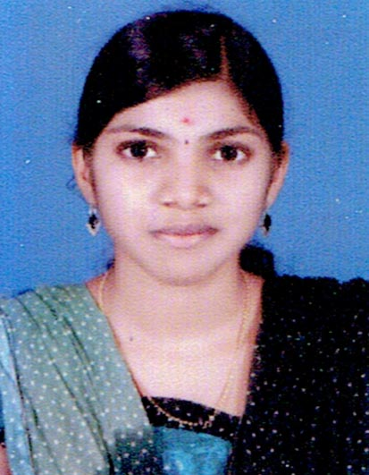

MANJUSHA.P.S
Mail ID: manjushaps18119@gmail.com
Mob: +91 8281929051

Looking for a challenging position with esteemed organization, where my skills and
experience will greatly enhance customer satisfaction, organizational success and
my own personal growth.

➢ Good Communication skills
➢ Able to work independently or as in group

➢ B-tech course(Computer Science and Engineering) completed 2013-2018
(Kannur University)
➢ HSE in Government V.H.S.S for Girls Kasargod (Board of Higher
Secondary Examinations, Government of Kerala-India) 2011-2013.
➢ SSLC – Government V.H.S.S for Girls Kasargod (Board of
Examinations, Government of Kerala-India) 2009-2011
PROFESSIONAL QUALIFICATION

➢ B-tech course(Computer Science and Engineering) completed

➢ MS Office, Word, Calc

HOBBIES

➢ Travelling & Listening Music
➢ Teaching
➢ Dancing

PERSONAL PROFILE

• Name : MANJUSHA.P.S
• Date of Birth : 19TH April 1995
• Nationality : Indian
• Marital Status : Married
• Languages known : English, Hindi & Malayalam

DECLARATION

In the above view of particulars, please consider this application and
request you to give me an opportunity in your esteemed organization.

Place: Kasargod Manjusha.P.S..

